Jared Ireland

BCIS309 – Work Integrated Learning PROJECT, Software dveelopment

Semester 2, 2023

Resource Management Solution for Cello

Project Proposal

Version 0.6

Contents

Introduction 1

Project Details 2

Project Name 2

Overview of Industry Client 2

Project Background 2

Project Scope 3

Project Goal(s) 3

Benefits of Project 3

Project Requirements 3

Expected Deliverables 3

Stakeholder Management 5

Project Hierarchy 5

Reporting and Meetings 5

Student Skills 7

General Skills Required 7

ICT Specific Skills Required 7

Skills from Relevant L6 and L7 Courses 7

Approach to Learning New Skills 8

Project Plan – High Level 9

Phases 9

Timetable 9

Burndown Charts 10

Detailed Project Plan 11

Risk Management 14

Approach 14

Risk Table 1

Quality Assurance 1

Approach 1

Quality Assurance Table 1

Methodology 3

Overview 3

Literature Review 3

Critique (Pros and Cons) 3

Professionalism 4

Professional Standards 4

Relevance of ITP Code of Ethics 5

Relevant Legislation 6

Sustainability, Inclusive Practice and Te Tiriti o Waitangi 7

Relevance of Principles to Student and Industry 7

References 8

Appendices 9

Document Control

The document control date is based on the start of the week aside from a few days as these are a final submission day.

|  |  |  |  |
| --- | --- | --- | --- |
| Date | Author | Version | Status of Document/Updates Made |
| 31/07/2023 | Jared Ireland | v0.1 | Document Creation. |
| 07/08/2023 | Jared Ireland | v0.2 | Created Initial Burndown Charts created. |
| 14/08/2023 | Jared Ireland | v0.3 | Added general skills.  Added overviews for all headings.  Preparing final parts of Document pre–Information Gathering.  Created Initial Quality Assurance Table.  Created Initial Risk Assessment Table |
| 21/08/2023 | Jared Ireland | v0.4 | Added Student Skills.  Added Professionalism.  Added Methodology.  Added Relevance to ITP Code of Ethics.  Added Sustainability, Inclusive Practice and Te Tiriti o Waitangi. |
| 25/08/2023 | Jared Ireland | v0.5 | Finalising document for first iteration  Sending to Industry for feedback  Sending to Academic Supervisor for feedback  Sending to Industry Supervisor for feedback |
| 28/08/2023 | Jared Ireland | v0.6 | Applying Academic feedback  Applying Industry feedback  Sending to Academic Supervisor for feedback  Sending to Industry Supervisor for feedback |
| 1/09/2023 | Jared Ireland | v0.7 | Initial Project Proposal submission |

# Introduction

The purpose of this project proposal is to show the project details, the information that has been gathered, the management and monitoring of possible risks, project scope, steps, frameworks, and ethics. this document to be used as a guideline as well as a detailed description for the client.

# Project Details

This section is to describe the project along with the information of the industry client and project background that contains current and future situations.

## Project Name

Cello Resource Management Solution

## Overview of Industry Client

Cello is a networking company who had started within CLL but was bought Spark’s operation and has since split away due to two networking businesses working within a business. Cello’s clients are strictly Business and Organizations and they, Cello, do not invest into the infrastructure as they leverage all the other vendors/partners, using the likes of Cisco, Juniper, Aruba, and Fortinet for hardware and Chorus, 2degrees, One for network infrastructure and run a solution-led organization, aggregating the best technologies both locally and internationally to ensure they have the right tools.

## Project Background

### Overview

Cello is maturing as a business after their divestment from Spark and is now creating their collateral, artifacts and improving or creating process. Cello has been growing a rapid pace over the past three years, jumping up from 30 staff members where, having quick conversations around who was on what project and what was scheduled, and making promises in terms of things to the clients, to over 100 staff members and various teams, all working on various projects with no holistic view of who and what’s been booked.

### Current Situation

* Inability to know what staff members are working on what projects.
* Double booking staff members.
* No holistic view of staff members and teams.
* Making sure being able to deliver on promises with Clients.

### Future Situation

Providing the business with an overview of the workflow within it. So, it will help with:

* Visibility of all engineering projects
* Planning projects.
* Estimating delivery times.
* Tracking progress within set time frames.

# Project Scope

**This section will be defining the Scope, Goals and Requirements for the project.**

## Project Goal(s)

### Industry

Develop a location to have a holistic overview of the company and visibility of scheduled works.

### Student

Developing the set requirements as set out by the Project Owner and Industry Supervisor’s.

## Benefits of Project

### Industry Being able to schedule work and agree on timelines with clients without overlap, without putting pressure on teams, having a future vision of the workload so that you know when you're going to need more resources in terms of recruitment.

### Student

* Ability to put teachings into practice.
* Developing working habits and job readiness as well as interpersonal and communication skills.
* Having a hand’s on and collaborative approach to working conditions
* Managing, Understanding, Prioritization, backlogging of tasks and being able to adapt to changing of tasks.

## Project Requirements

**Outlining high-level requirements.**

## Expected Deliverables

### Academic

* Weekly summarization reviews
* Continuously maintained burn-down charts, risk assessments and quality assurance
* Project Proposal, Proposal Checklist, Project Proposal Approval Form
* Methodology Essay
* Halfway Project Report
* Industry and Academic Supervisor Assessment
* Final Report
* Short Paper
* Project Poster
* Panel Presentation

### Industry

* Weekly check-ins/progress updates
* Testing Phase - meeting user requirements
* Stakeholder Meetings – Feedback and making the solution is meeting.
* SOP’s - Manual Documentation – using Cello template.
* Potential Deployment
* Visibility of Engineering ‘Calendars’ in one Spot.
* Ability to book time for different teams.
  + Inclusive of Staff Leave times.
* Dual view is required as we would need to view.
  + NOC (Network Operations Centre)
  + Engineering (WAN, LAN & Security) planned schedules.
* Design for the SharePoint (Only used to serve as a front-end display)
  + Simple design
  + Little customisation
* Cello Staff Management
  + Current Staff Status (Leave/Not on leave)
* Calendar connection [todo]
* Integration’s
  + AutoCello
  + Office 365
  + Power Apps / JavaScript

# Stakeholder Management

This section will state who the Industry and Academic stakeholders are, who are involved in the development and completion of this project. This will include names, organisation, roles, and contact details. There will also be the addition of Reporting and Meeting time schedules that will ensure the project is staying on track, meeting the objectives, and overall being completed on time.

## Project Hierarchy

|  |  |  |  |
| --- | --- | --- | --- |
| Name | Organisation | Role | Contact |
| Rik Rogers | Cello | Director of Operations  Project Owner | [rik.rogers@cello.co.nz](mailto:rik.rogers@cello.co.nz) |
| Stephen Penfold | Cello | Network and Security Engineer  Industry Supervisor | [stephen.penfold@cello.co.nz](mailto:stephen.penfold@cello.co.nz) |
| Jodi Anderson | Cello | Business Manager  Industry Supervisor | [jodi.anderson@cello.co.nz](mailto:jodi.anderson@cello.co.nz) |
| Jared Ireland | Ara Institute of Canterbury Ltd. | Ara Institute of Canterbury Ltd. Student Full Stack Developer | [jared.ireland@cello.co.nz](mailto:jared.ireland@cello.co.nz) |

|  |  |  |  |
| --- | --- | --- | --- |
| Name | Organisation | Role | Contact |
| Dr David Weir | Ara Institute of Canterbury Ltd. | Academic Manager and Course Convenor | [david.weir@ara.ac.nz](mailto:david.weir@ara.ac.nz) |
| Peter Edge | Ara Institute of Canterbury Ltd. | Academic Supervisor | [peter.edge@ara.ac.nz](mailto:peter.edge@ara.ac.nz) |
| Jared Ireland | Ara Institute of Canterbury Ltd. | BICST Student | [jai0095@arastudent.ac.nz](mailto:jai0095@arastudent.ac.nz) |

## Reporting and Meetings

Meetings will be held either in person or via videoconferencing tools (Zoom, Teams etc)

|  |  |  |  |  |
| --- | --- | --- | --- | --- |
| Name | Role | Meeting Agenda | Data and Time | Location |
| Dr David Weir  Phillip Roxborogh | Course Convenor  Lecturer | BCIS309 Class Attendance | Monday 3-5pm  Thursday 1-3pm | S169 |
| Jodi Anderson  Rik Rodgers  Stephen Penfold | Product Owner  Industry Supervisor | Initial Meeting | Wednesday 2nd August 2-2:30pm | Face to Face Christchurch Cello Offices |
| Information Gathering Meeting | Tuesday 22nd August 11:15am-12pm | Microsoft Teams |
| Jodi Anderson  Puneeth Anandaraj | Industry Supervisor  Cello Developer | Discussion around the AutoCello API | Friday 1st September  10am-10:30pm | Microsoft Teams |
| Jodi Anderson | Industry Supervisor | Project Proposal Review | Friday 1st September  2:20pm-2:50pm | Microsoft Teams |

### Academic Weekly Reports

Academic weekly reports will be documented here when they have been completed. The purpose of this meeting is to check the progress of following documentation project proposal, risk assessment, burndown chart and quality assurance while the academic supervisor gives feedback and suggestions on improvement. These meetings will either be held face to face at Ara or on Microsoft Teams. Documents will need to be given over prior to the weekly meeting for Academic Supervisor to be able to review and make comments for the meeting.

|  |  |  |  |
| --- | --- | --- | --- |
| **Date** | **Provided Documents** | **Activity** | **Takeaway** |
| 29/08/2023 | Project Proposal | First meeting. Discussed contents of project proposal and what the next steps are going to be. | Academic writing style should be used throughout the whole project.  Sending an earlier version (1/4 to ½ done) should have been done to get feedback and be steered into the right direction. |

# Student Skills

This section describes the projects required skills, ICT specific skills, skills relevant from BICT teachings and approach to learning of new skills.

## General Skills Required

* Time Management
* Collaboration
* Communication
* Problem Solving
* Risk Management

## ICT Specific Skills Required

* Microsoft SharePoint
* Git
* GitHub
* Visual Studio Code

## Skills from Relevant L6 and L7 Courses

**BCDE321 Advanced Programming – L7**

* Bad Smells
* Refactoring
* Design Patterns

**BCDE311 Software Development Project – L7**

|  |  |  |  |  |
| --- | --- | --- | --- | --- |
| HTML | CSS | Project Planning | Project Proposal | Functional Testing |
| User Reporting | Risk Management | Iterative Prototyping | Specification Documentation | Usability Testing |
| Responsive Design | Design Thinking | Accessibility | Agile Methodologies | High and Low Fidelity Design |
| Project management frameworks | ITP NZ Ethics and Guidelines |  |  |  |

**BCIS303 Information Technology Governance – L7**

|  |  |  |  |  |
| --- | --- | --- | --- | --- |
| Thematic Analysis | Qualitative Analysis | High level Analysis | Systematic data gathering | Collaborative teamwork |
| Engagement and Input | Data Coding | Planning Skills | Strategic Analysis | Strategic Evaluation |

**BCDE215 Web Development – L6**

|  |  |  |  |  |
| --- | --- | --- | --- | --- |
| HTML | CSS | Bootstrap | Django | Ecommerce Platform |
| AWS Website Hosting |  |  |  |  |

**BCDE223 Best Programming Practices (Java) – L6**

|  |  |  |  |  |
| --- | --- | --- | --- | --- |
| Coding Language | Unit Testing | Class Diagrams | MoSCoW | Android Studio |

**BCDE222 Best Programming Practices (C#.NET) – L6**

|  |  |  |  |  |
| --- | --- | --- | --- | --- |
| Coding Language | Unit Testing | Class Diagrams | MoSCoW | Visual Studio |

**BCDE224 Best Programming Practices (Server-Side Programming – PHP) – L6**

|  |  |  |  |  |
| --- | --- | --- | --- | --- |
| PHP Development | MySQL Language | Schema Development | Database Diagram | User Stories |
|  |  |  |  |  |

## Approach to Learning New Skills

* Research
* Identify Learning Resources
* Practicing from resources

# Project Plan – High Level

The following section will outline the project management framework that will be administered and being discussed in detail. A timeline will be updated for any additional changes.

## Phases

During the project the use of Kanban will be used as the project management methodology. Though this is talked about more in the Methodology section, Kanban allows for the full transparency, responsibility and visual representation of work that has been broken down into task. The below outline is what the phases will look like:

* **Discovery**
  + **What’s currently being used.**
  + **What could be used.**
* **Design**
  + **Wireframe solutions.**
  + **Low Fidelity design.**
  + **High Fidelity design.**
* **Develop & Build** 
  + **Iterative development.**
  + **Weekly progress meetings.**
* **Testing & Review**
  + **Develop test cases – Software testing.**
  + **Develop user test cases – Human testing.**
  + **Review with Stakeholders**

## Timetable

Weekly meetings to discuss and determine the following week of work based on Microsoft Planner.

Completion Date: 16th November 2023

## Burndown Charts

### Industry

Figure 1

*Industry Burndown Chart*

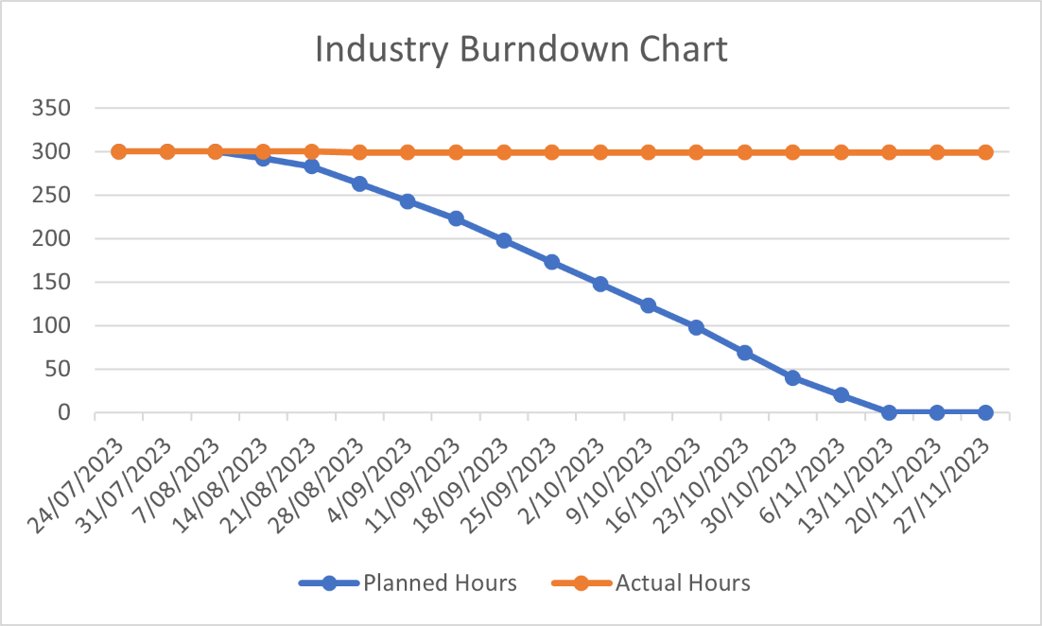

### Academic

Figure 2

*Academic Burndown Chart*

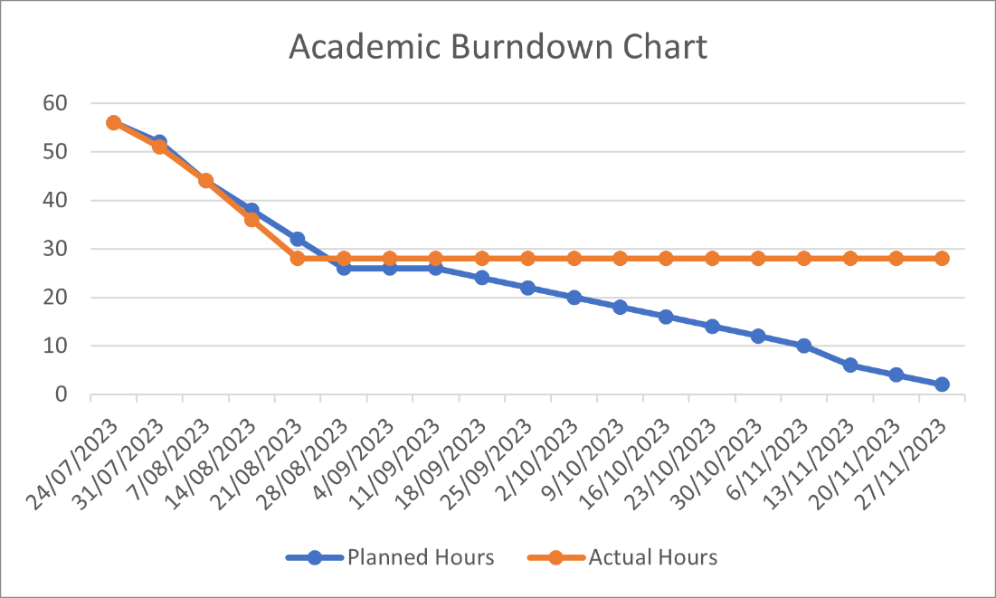

Resources/Access Required

Software

* Git
* Microsoft Office 365
* AutoCello access
* Power Apps access

Hardware

* Internet access
* Personal device

## Detailed Project Plan

Organisation: Cello

Project Title: Resource Management Solution

Project Owner: Rik Rogers

Industry Supervisors: Stephen Penfold and Jodi Anderson

### Academic

Table 1

*Detailed Plan for Academic Hours*

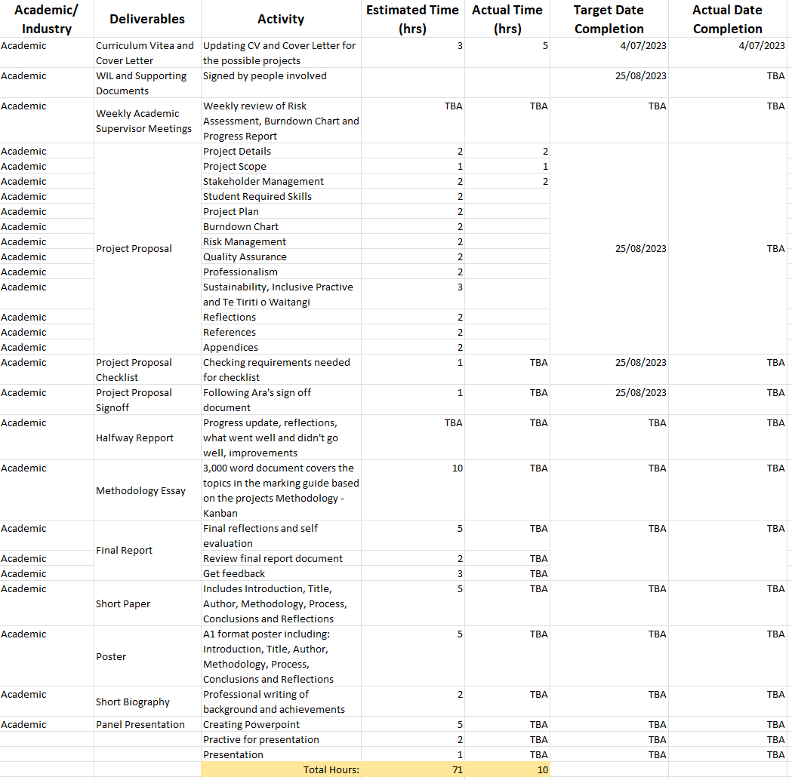

Industry

Table 2

*Detailed Plan For Industry Hours*

*Notes*: Monday 4th of September is another meeting with Jodi and Stephen to discuss target completion dates

# Risk Management

**This section will be discussing the approach to Risk Management that has been taken. A risk table that covers business, project and personal risks will be attached.**

## Approach

Risk assessment is a critical part of project management as it helps identify potential threats and opportunities, allowing project managers to make informed decisions, develop mitigation strategies and allocate resources efficiently to minimize the potential negative impacts during a project. By evaluating the risks across various themes such as scope, schedule and quality, project teams can have their abilities enhanced to deliver a successful product while adapting to changes and maintaining project stability and stakeholder satisfaction.

The project has two objectives, an academic and an industry outcome, each containing their own risks that need to be well managed to have both outcomes kept on track and delivered at an appropriate time and quality. The academic risk table consists of risks associated to the deliverables within the academic outcome and what can cause impact, the industry risk table does the same for the industry outcome. Though these risks can be similar they will be largely different due to the nature of each subproject.

The risk assessment table that will be used is a modified version of the Microsoft Risk Assessment Template and the addition of the Virginia Tech ITPM Matrix. This combination eliminates the arbitrary numbers that the Microsoft Risk Assessment table would have when applying it to the both the academic and industry dimensions and is replaced by the Matrix system from Virginia Tech’s IT Project Management resource which also brings more understanding to the scale. A set of response strategies has also been added to indicate how each risk will be tackled if it occurs and what the attempts of mitigation will be. A set of response strategies has also been added to indicate how each risk will be tackled with as well as plans to attempt to mitigate the risk of happening. Risks, if it happens, will have to be accepted which primarily effects the risk of health though if a risk was to happen contacting project managers will be the first process to undertake and a planning session will be completed on what to do during and after this risk.

Based on weekly meetings with the academic supervisor the Risk Assessment tool, along with other documentations, will be reviewed and talked about to understand what could potentially be causing issues as there is both a mix of personal and schedule risks within the first assessment of risk. Personal risks evolve around contingencies such as personal health disruptions which may impede task executions. Schedule risks pertain to the potential delays in deliverables owing to variables like misinterpretation of requirements or scope escalation.

## Risk Table

Table 3

*Initial Risk Assessment*

# Quality Assurance

Quality Assurance is a systematic process and activity series implemented to ensure that products meet specific quality standards and requirements.

## Approach

The focus of quality assurance is on the processes used in the project. Quality assurance ensures that project processes are used effectively to produce quality project deliverables. It involves following and meeting standards, continuously improving project work, and correcting project defects. (Virgina, n.d.)

Two QA tables will be generated in order to assist with the whole encompassing project of Academic and Industry work. These QA tables will be a reference point to understand what is needed to ensure high level work has been done and will be checked off be required persons. Virgina Tech template outlines five key points: Expected Deliverable, Deliverable Standard, Quality Control Activity, Frequency (of checking) and who is responsible. Modifications will be made to this to better fit the current processes around this project. Who is responsible gets replaced with Signee/s and Date Accepted to indicate when the quality of the deliverables has met an acceptable standard.

## Quality Assurance Table

Table 4

*Industry Quality Assurance*

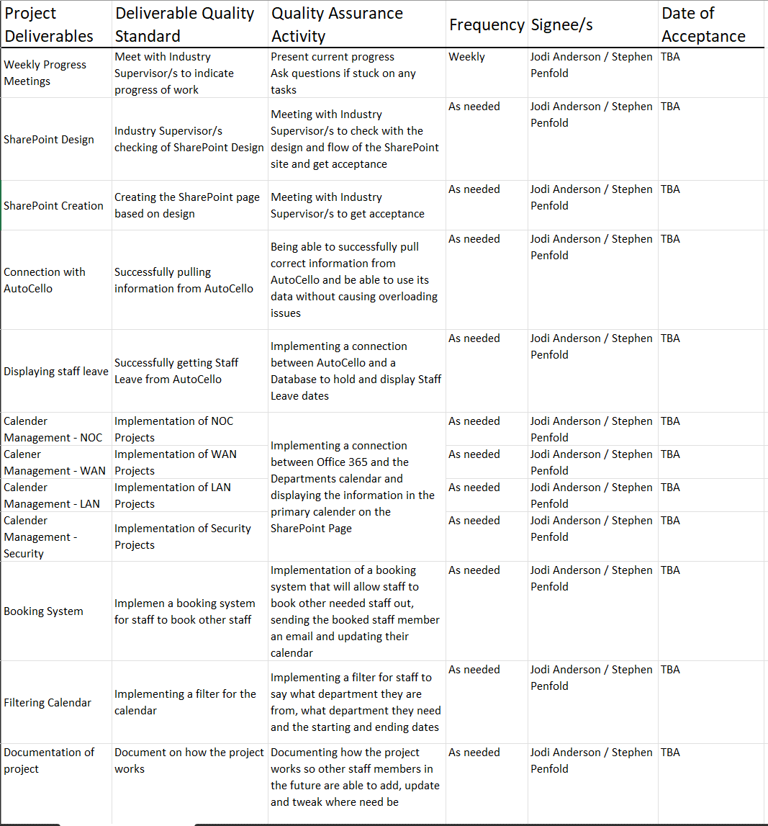

Table 5

*Academic Quality Assurance*

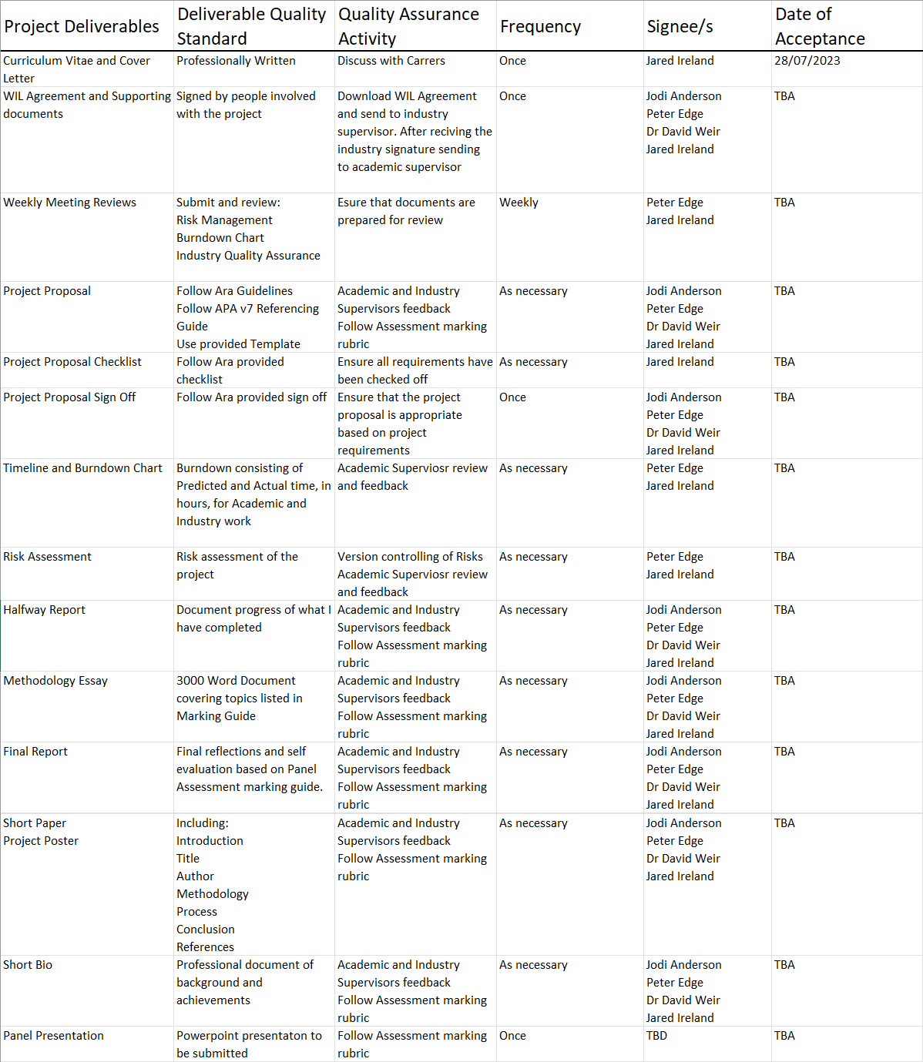

# Methodology

This section highlights the method and approach that will be used for the project. The literature review discusses the Kanban Methodology. A Critique of Kanban will also be included.

## Overview

Kanban will be used as the primary project management methodology due to its transparency of work and visual representation of workflow, as well as the philosophy of giving enough work to team members so that they are working at capacity while not overbearing team members with too much work. Kanban also allows for flexible planning, giving clear focuses, and clear transparency of work. Kanban shows critical information of the particular work item giving full visibility into who is responsible for that item as well as a description of the work being done, estimated working time and other information. Cards can also hold other information such as screenshots of designs and other valuable information for the assigned worker. This allows for team members to see the state of all work items at any point in time, the associated details, ensuring increased focus with full traceability and fast identification of roadblocks and dependencies.

## Literature Review

Kanban is a popular framework used to implement [agile](https://www.atlassian.com/agile) and [DevOps](https://www.atlassian.com/devops/what-is-devops) software development. It requires real-time communication of capacity and full transparency of work. Work items are represented visually on a [kanban board](https://www.atlassian.com/software/jira/templates/kanban), allowing team members to see the state of every piece of work at any time. (Radigan, n.d.)

The main purpose of representing work as a card on the kanban board is to allow team members to track the progress of work through its workflow in a highly visual manner. Kanban cards feature critical information about that particular work item, giving the entire team full visibility into who is responsible for that item of work, a brief description of the job being done, how long that piece of work is estimated to take, and so on. Cards on virtual kanban boards will often also feature screenshots and other technical details that is valuable to the assignee. Allowing team members to see the state of every work item at any given point in time, as well as all of the associated details, ensures increased focus, full traceability, and fast identification of blockers and dependencies. (Radigan, n.d.)

Kanban aims to give team members just enough work so the team is consistently working at capacity. Teams that practice kanban benefit from flexible planning, clearer focus, and total transparency because whatever’s on the board is the top priority. That’s what developers are working on. Kanban is great for operational teams focused on continuous delivery with changing priorities. (Daly, n.d.)

## Critique (Pros and Cons)

**Pros**

* Flexibility and Adaptability to changing requirements and priorities
* Continuous Improvement via retrospective and data driven decision making
* Enhance Visibility in clear and real-time view of tasks and their statuses

**Cons**

* Lack of structure can cause the Flexibility to be a weak point
* Limited predictability in the likes of delivery dates
* Dependency on tasks being clearly defined

# Professionalism

Professionalism maintains a high standard of conduct, behaviour and ethics which contribute to the success of the project.

## Professional Standards

The quality of my project should match the expectations of the Academic and Industry Stakeholders. I will be following ethical standards and guidelines throughout the project and maintaining my work ethic by protecting confidential information and not making the project for personal gain, outside of academic value.

### Reliability and Accountability

Working effectively to maintain deadlines, promises and expectations within my project to ensure that the project is completed and successful while also taking ownership and being accountable for any actions during this time.

### Communication

Being clear in all forms of communication between Academic and Industry Supervisors, as well as any team members. To avoid misunderstandings and confusion, there will be limits on the content in which will be sent. Listening actively during meetings and to team members and stakeholders to understand their wants, needs and any feedback.

### Attitude

Despite potential emotional challenges there will be during the short project timeline, keeping a positive attitude towards work while being honest and ethical. Working collaboratively with supervisors and colleagues while maintaining a positive attitude and being a supportive column.

### Teamwork

Partaking in open communication to allow for the development of collaborative work and ideas, while also letting others be able to voice their queries, concerns, opinions, and ideas.

### Motivation

Motivation gives way for commitment to excellence, ethical behaviours and continuous improvement allowing for myself to excel in the project, overcome boundaries and surpass expectations.

### Open to Learning

This project is a great opportunity to learn, develop and hone skills while also not being hesitant to ask for clarifications and help.

## Relevance of ITP Code of Ethics

This section provides and overview of the ethical considerations I will be adhering to during the project and after the project. This section is based on the ITP Code of Ethics and their eight tenets which are interconnected and cover significant aspects of Ethics and Behaviours.

### Good Faith

### Treating individuals with respect, equality, and fairness, without any discrimination, is a fundamental principle that should guide our actions. It is important to be mindful of the beliefs and cultural sensitivities of all community groups that may be impacted by our work.

### Integrity

### Working with honesty and respect, and using our abilities to positively impact society, is crucial in gaining the trust of both individuals and the industry. To prioritize the client's needs, it is essential to conduct thorough research and implement methodologies with honesty and integrity.

### Community Focus

### The most important thing is to prioritize the well-being of the community above everything else. The community should always be the main focus when working on a project.

### Skills

### Utilize skills and knowledge to deliver high-quality work for the project outcome. Problem-solving and decision-making skills will be applied to find solutions and make informed choices in order to keep the project on track in the face of challenges.

### Continuous Development

### Continuously enhancing knowledge, skills, and experience throughout one's career and encouraging colleagues to do the same.

### Informed Consent

### The commitment is to ensure that any potential economic, social, environmental, or legal consequences of actions will be reported to clients or companies in a reasonable manner.

### Conflicts of Interest

Recognising and handling conflicts of interest are vital to ensure actions align with ethical standards.

### Competence

To follow established professional standard, providing services and advice solely within one’s area of expertise

## Relevant Legislation

Guideline – see <https://www.privacy.org.nz/> and <https://www.iponz.govt.nz/> - - capture how you will make sure you will meet relevant legislation requirement

Privacy/Confidentiality

As per contract with Cello, the Project Owners, I will be following the New Zealand 1993 Privacy Act in which the purpose of collection shall only be collected for lawful and necessary purposes related to the functions of the organisation that is controlling it.

Copyright

As per contract with Cello, the Project Owners, all intellectual property that I will be creating will be owned by Cello.

# Sustainability, Inclusive Practice and Te Tiriti o Waitangi

This section discusses the relevance of principles between Student and Industry throughout the entirety of the project.

## Relevance of Principles to Student and Industry

By developing an understanding of relevant principles, I will be able to apply them in my works and try to be aware of the principles ensuring that my works respect them which brings team members together and allow for an easier working space.

### Kaitiakitanga

Monitoring and evaluating the project can identify areas where changes need to be made to be kept in line with the Kaitiakitanga principles of respecting the environment and cultural values while still being sustainable and responsible.

### Rangatiratanga

Developing an involved open discussion establishes collaborative work and enables open communication allowing for the freedom of creativity and expression of ideas and perspectives.

### Whanaungatanga

Encouraging collaborative work and having open minded discussions to enable everyone to have a voice will help develop relationships and bring team members together.

### Mana Reo

I will use relevant languages with the project team so that they are comfortable and can enhance cultural awareness.

# Reflections

# References

Daly, L. (n.d.). *Kanplan*. Atlassian: https://www.atlassian.com/agile/kanban/kanplan

Radigan, D. (n.d.). *Kanban*. Atlassian: https://www.atlassian.com/agile/kanban

Virgina, T. (n.d.). *Virgina Tech Project Management Standard*. Virgina Tech: https://it.vt.edu/projects/project_management.html

# Appendices

This section contains appendices to provide additional information.

Appendix A: Burndown Chart

Showing differences in versions.

Figure

*Academic Burndown Chart (week 21 August 2023)*



Figure

*Academic Burndown Chart (Week 28 August 2023)*

Appendix B: High Detail Plan

Showing differences in versions.

Table

*High Detail Plan (Industry) version 1*

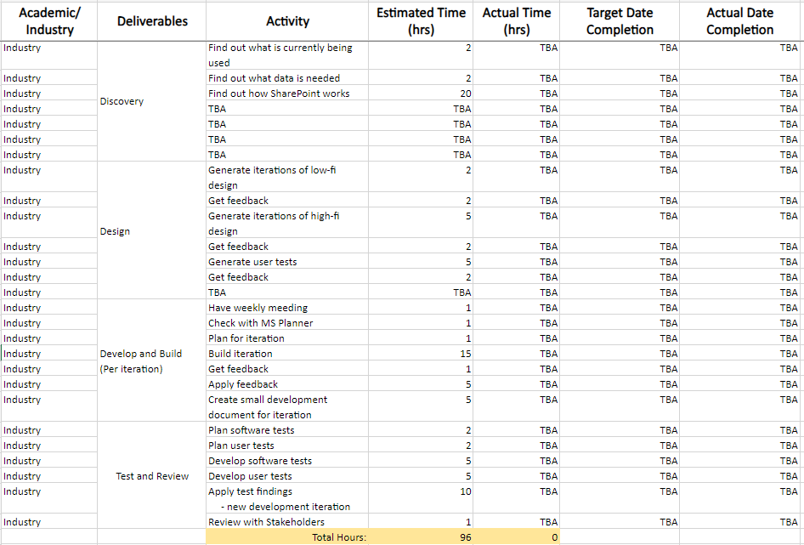

Appendix C: Risk Assessment

Showing differences in versions.

Table

*Risk Assessment version 1*

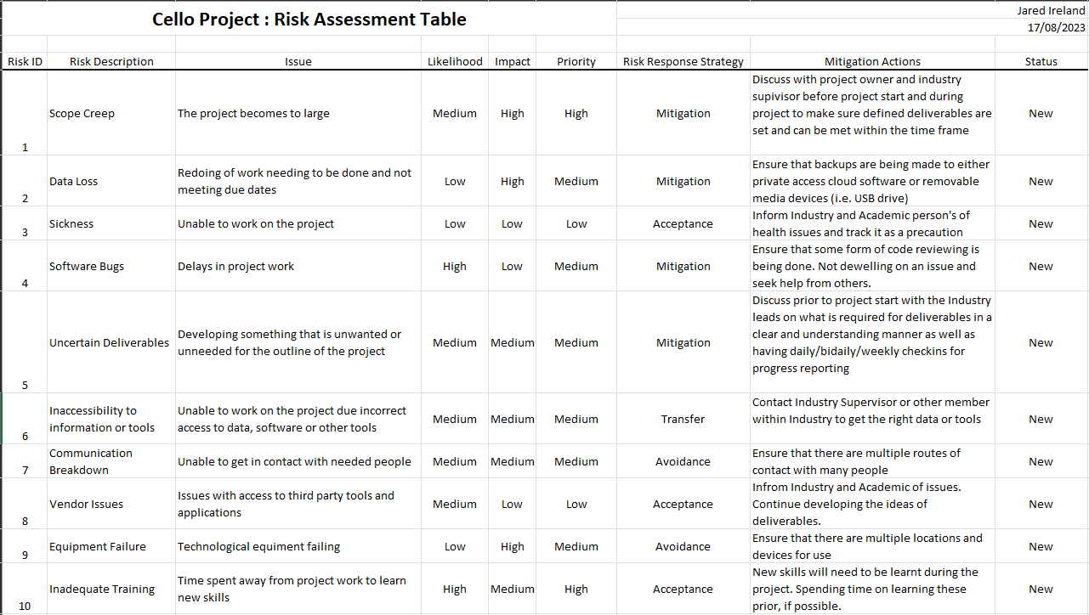

Table

*Risk Assessment version 2*

*Note:* removed risks have been added to event log found in the same document.

Appendix D: Quality Assurance

Showing differences in versions.

Table

*Academic Quality Assurance version 1*

Appendix E: Timesheet

Showing differences in versions.

Table

*Timesheet week 28 August 2023*

